Sprint 2 Retrospective - Project Demo - Notes

# Group Members

|  |  |  |
| --- | --- | --- |
| Name | Student ID | Grade |
| Harshit Saxena | 218699327 | HD |
| Jack Lenigas | 218138603 | D |
| Rina Kouch | 219162014 | D |
| Tushar | 217575769 | HD |
| Dinul Perera  Gaoyuan Xing | 218460699  219500173 | C  C |

# Presentation

* Script and presentation will be based on the responses to the tasks below and you won’t need to edit either document.
* Rina will be copying and pasting your section into the presentation and adding images where appropriate.
* If you have an image you would like to include, please paste it in your section followed by a link to the original source.
* Presentation Link:   
  https://docs.google.com/presentation/d/1wli2iivejuQWgGwrP6Kc50ALUpM0G3Q6DxuxfMllUr4/edit?usp=sharing

# Tasks

Notes

* Please put any references as appropriate

Task List

1. DONE - Overview of your group activities  
   The person in charge: Rina  
   Currently: Done
2. DONE - Issues you faced during your sprint (what worked and what didn’t)  
   The person in charge: Jack  
   Currently: Done
3. DONE - Your technology stack (i.e. which technologies are you planning to use for the implementation of the project including details of the following:
   1. DONE - Programming language and technology you will be using  
      The person in charge: Tushar  
      Currently: Done

|  |  |
| --- | --- |
| Front-end technologies | HTML, CSS |
| Back end technologies | PHP |
| Database | MySQL |
| Operating system | Linux |
| Communication b/w Front-end and Back-end | Ajax |
| Security technology | Amazon Web Application Firewall |
| Caching system | Memcached |
| Server for web application | Apache |

* 1. DONE - Mock UI/UX designs  
     The person in charge: Rina  
     I’ll put them directly into the presentation when I’m able to.  
     Currently: Done
  2. DONE - Security issues and how you plan to secure your system  
     The person in charge: Jack

Currently: Done

* 1. DONE - Data storage plans and schemas (the plan represented as a diagram) (if applicable)  
     The person in charge: Tushar  
     Currently: Done

Your presentation should adhere to the following presentation rubric:

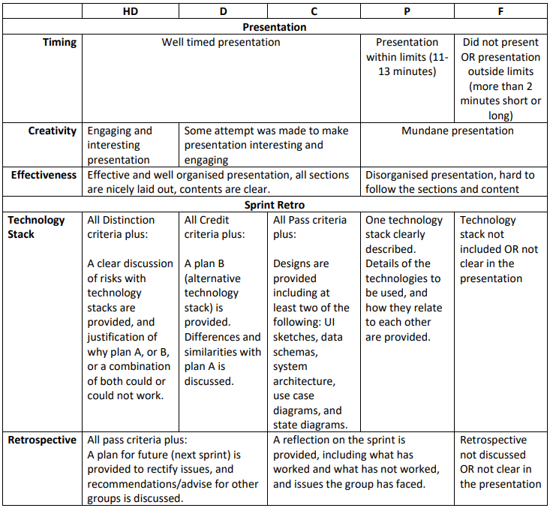

Group Activities - Sprint Planning

**Sprint Planning Meeting:**

Segregation of tasks between sprint 2 backlog and product backlog

Discussion on different stack choices and technologies to be used for research

Assignment of tasks to each member

**Individuals worked on their assigned tasks between planning meeting :**

Brief opening on how the project has to be carried out

Stack A and Stack B created and technologies assigned

Group Activities carried out for each task

**Daily Meetings:**

Members informed about stack and technologies

Reasons justifying which stack preferred for the project

Discussion of ethical problems associated with our product and assigning team members with questions

Discussed project document and allotment of section of document to each team member

**Individuals worked on their assigned tasks :**

Stack justification

Identifying ethical issues

Problem solving of ethical issues regarding our product

Working on project document

**Issues Faced During Sprint 2**

Lack of knowledge of web tools for application of our model

Lack of knowledge about various stack combinations that can be used

Humongous workload in short time span

Managing different commitments and other’s schedule

Equal contribution of all team members for 10.1 as there was not much to do

**What Worked and What did not**

● **What worked :**

○ Organizing team meetings on Microsoft Teams including everyone’s availability and finalizing a time slot

○ One google doc which everyone had access to show work done by others and for editing purposes

○ Setting deadlines and asking team members to adhere to those deadlines to get the job done wat before the actual deadlines

● **What didn’t work :**

○ Exact and in depth understanding of what was expected for our product

**How to Improve for Future Sprints**

● More in depth research and concrete task assignments to the members

● Elaborate explanation and research work for those members who did not understand at once

● Distribution of workload to all members so that high quality of work and lesser personal workload is maintained

**Suggestions for other groups:**

● Making sure all group members have clear idea about the product and our project model

● Using alternate options for team meetings like Skype , Zoom

● Giving team members much needed freedom to do the work in the way they want considering the work is done keeping in mind about the deadline and quality

# Technology Stack A

|  |  |
| --- | --- |
| Front-end technologies | HTML, CSS, Balsamiq, Adobe XD |
| Back end technologies | PHP, LAMP |
| Database | MySQL |
| Operating system | Linux |
| Communication b/w Front-end and Back-end | Ajax |
| Security technology | Amazon Web Application Firewall |
| Caching system | Memcached |
| Server for web application | Apache |

# Technology Stack B

|  |  |
| --- | --- |
| Front-end programming languages | HTML, Tailwind CSS, React.js, Next.js |
| Back end programming language | Java |
| Database | MongoDB |
| Operating system | Windows server |
| Communication b/w Front-end and Back-end | Express.js |
| Security technology | Azure Web Application Firewall |
| Caching system | Redis |
| Server for web application | Node.js & Nginx |

**ADAVANTAGES OF PLAN A OVER PLAN B**

**Front-end**

|  |  |
| --- | --- |
| **Plan A** | **Plan B** |
| Adobe XD is preferred simply because its known for its rapid prototyping design applications and can be extremely useful in producing a good design | Axure RP is rather used as a backup to tackle complex and time consuming situations and hence Axure assists in modification of the deign |
| JavaScript is the best because it enhances user experience by making the website more interactive and also it cannot be replaced by J Query | jQuery is a library of JavaScript. It is smaller version of Java Script i.e. used to do common scripting functions in a much shorter code . Also it lacks all the features and codes that Java Script has to offer |

**Back-end that consist our database**

|  |  |
| --- | --- |
| **Plan A** | **Plan B** |
| LAMP technology stack is based on Linux OS which is significantly used in the field of programming. What more it gives the designers more freedom and room for experimentation through its customisable inbuilt rules and syntax | MEAN technology stack is a cross platform stack so it helps in eliminating one of key issues. For instance we always ensure that hardware has required drivers all available before installing any hardware component to our system. So the problem is that the hardware manufacturers have standard drivers for windows but not all brands does the same for Linux OS |
| In LAMP PHP is used for programming which is more prominently used for back end programming . Being open source it is not only cost effective but also has massive community support | In this technology stack Java Script plays an instrumental role. The Php server side is usually replaced with the expressJS which enables a layer of features as compared to its counter part Node.Js and hence it is this combination that helps in running Java Script for back end perspective as well |
| MySQL plays essential role in any RDBMS as it can easily store colossal data and represent data in form of columns and rows | MongoDB in DBMS stores data in JSON file making the data more readable as compared to CSV file format which MySql supports |

**Security**

|  |  |
| --- | --- |
| **Plan A** | **Plan B** |
| SQL is highly preferred for any RDBMS owing to its capability to not only store , organise and represent any kind of massive data | Its just that Java Script gives more flexibility as compared to strict environment of mySql which cannot be much manipulated |

**Stack Recommendation**

Stack A is our preferred stack

As shown by Stack comparisons

Stack A seems to be upgraded and better integrated stack

